Crowfunding Campaign Analysis

Prepared by John Ellis (November 2, 2023)

# Conclusions

1. The most popular campaign category to run is a Theater campaign. This campaign category is twice as popular to run than film and video campaigns and music campaigns which are the second and third most popular campaigns, respectively.

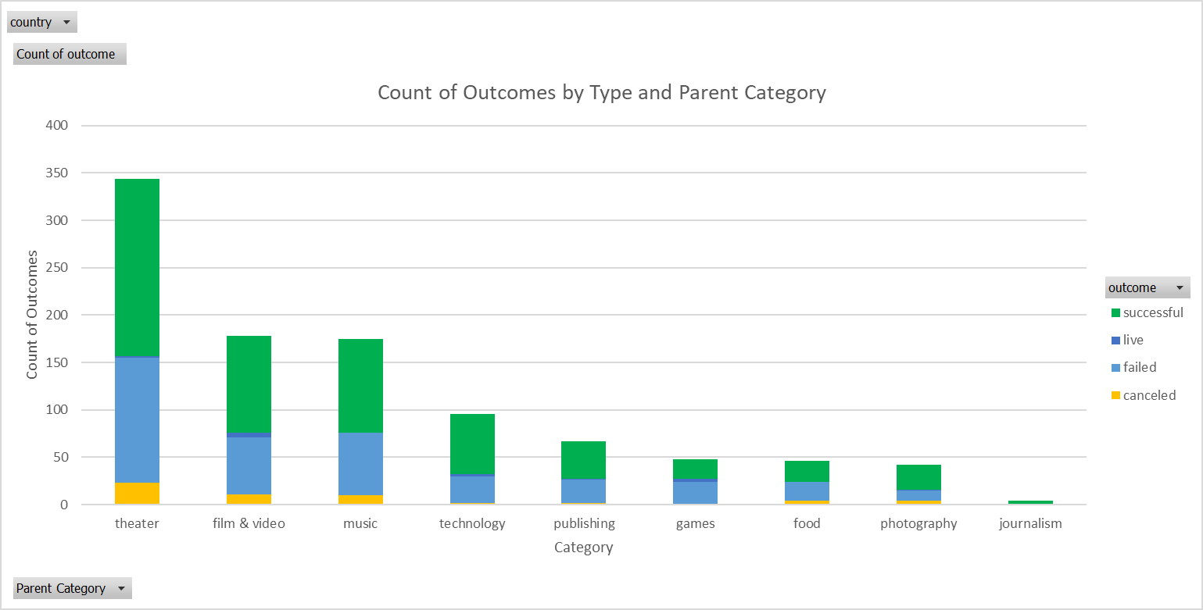

1. Within the Campaign Sub-Categories, the plays sub-category within the theater category was by far the most popular sub-category campaign to run.

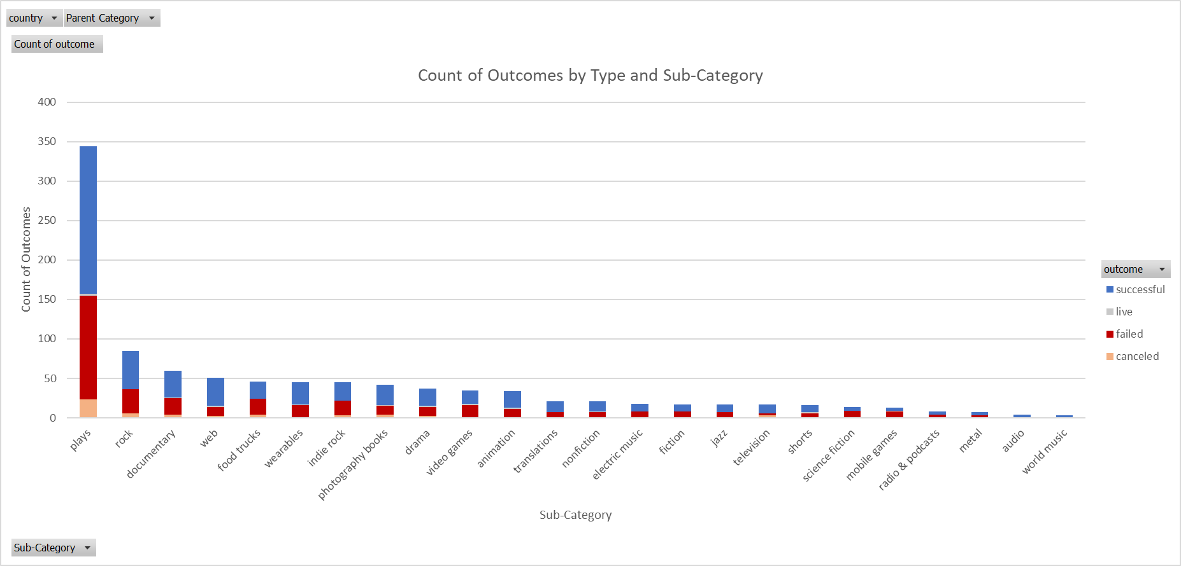

1. June and July are the months with the highest rate of successful campaigns.

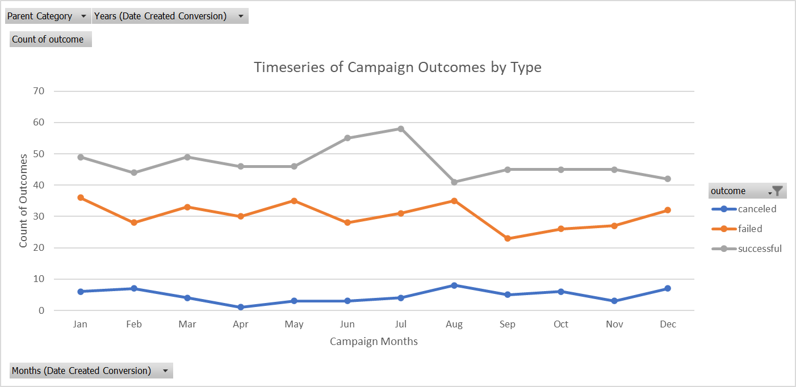

# Data Limitations

* The goal and pledge values are in multiple currencies. As such comparisons of goal and pledge values lack clarity due to differing currency values (IE. A pledge of one hundred Australian dollars is not equivalent to a pledge of 100 US dollars).

# Suggested Modifications for further analysis

1. Using the “Date Created Conversion” dates and the “Date Ended Conversion” dates, create a “Campaign Duration” column (Date Ended – Date Created) and create a scatter plot which plots the count of successful campaigns against the campaign duration to determine if there is a relationship between campaign duration and campaign success. Create the same chart but relating the duration to failed campaigns.
2. Normalize the goal and pledge data to a common (base) currency. Care would need to be taken to ensure the exchange rate used is for the appropriate day/month on which the campaign being treated ended (the date the campaign was created could also be used but the date ended is more reflective of value earned)[1]. Once this conversion is complete a wide array of monetary value-based comparisons can occur such as:
   1. A timeseries analysis of pledged data to determine when the most funds are raised.
   2. Modify the Category and Sub-Category bar graphs replacing the count of outcomes with the average of pledge values per backer converted to the base currency. This will help identify which category and sub-category of campaigns generate the most interest based on pledge level.

1. https://stackoverflow.com/a/3157187/22678955